

**Summer Technology Day Camp**

Alphapointe Technology Camp is a week-long day camp experience for Missouri & Kansas middle and high school students with vision impairments (ages 12-18).

Kids should know that this will not simply be an extension of school but will be FUN..... Facebook, music, & game apps included! Campers will learn to utilize various technologies that will impact their academic development, improve their internet navigation, and social networking knowledge & safety.

In addition to hands-on technology learning, campers will have an opportunity to meet and work with a variety of mentors who have successfully utilized technology in their chosen careers as professionals with vision loss.

Students are selected for this program through **nominations by Teachers of the Visually Impaired**. Nominations will begin **February 2015**.

The cost for Tech Camp is $50 however; the camper must attend all 5 days to receive a free gift for completing camp. Scholarships are available if needed.

**2015 Dates**: July 27st- 31th Monday through Friday

Sponsored by: Alphapointe 7501 Prospect, Kansas City, MO 64132

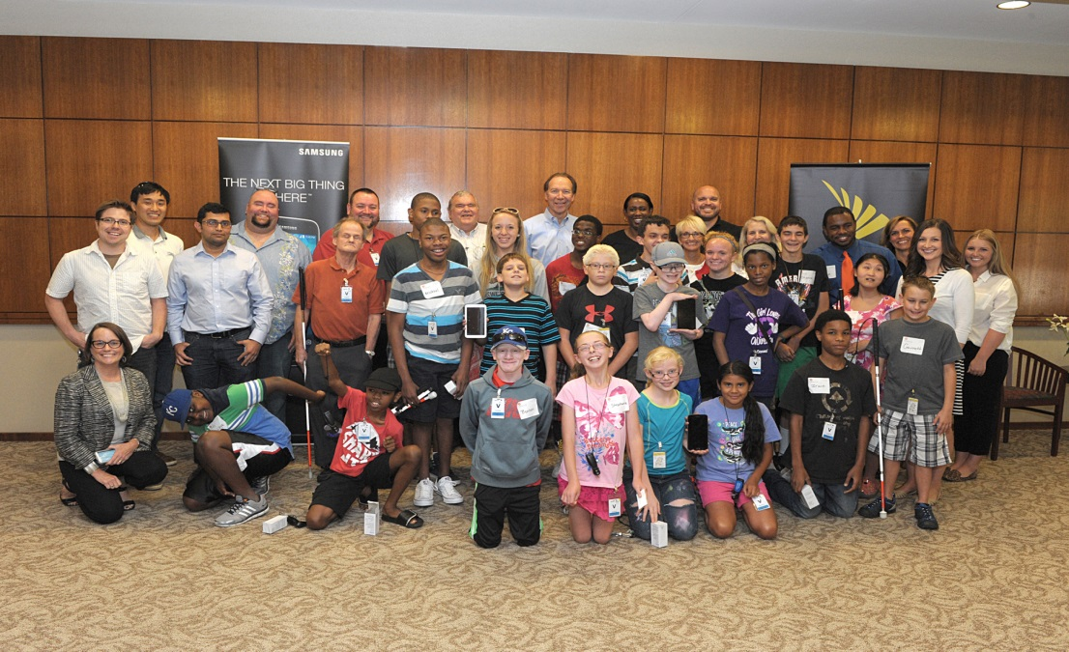

For questions: Jake McLaughlin, or Clay Berry at (816) 421-5848

[jmclaughlin@alphapointe.org](mailto:jmclaughlin@alphapointe.org) or [cberry@alphapointe.org](mailto:cberry@alphapointe.org)



**Technology Camp**

**Nomination/Registration Form**

Student Name: ________________________________________________________________

Parents Names: _________________________________________________________________

Address: ______________________________________________________________________

______________________________________________________________________________

Phones (home): ________________________Phones (cell or work): _______________________________

E-mail(s):_____________________________________________________________________________

Age: __________ Current Grade: _________ School: __________________________________________

Teacher for visually impaired (TVI): _______________________________________________________

TVI Phone : ________________________________ E-mail: _____________________________________

Visual Diagnosis: _______________________________________________________________________

_____________________________________________________________________________________

Other considerations: ___________________________________________________________________

_____________________________________________________________________________________

Description of current technology skills: _____________________________________________________________________________________________

Fax or e-mail completed form to (816) 237-2065 or

[cberry@alphapointe.org](mailto:cberry@alphapointe.org) [jmclaughlin@alphapointe.org](mailto:jmclaughlin@alphapointe.org)