

**Summer Technology Camp**

Alphapointe Technology Camp is a week-long day camp experience for Missouri & Kansas middle and high school students with vision impairments (ages 12-18).

Kids should know that this will not simply be an extension of school but will be FUN..... Facebook, music, & game apps included! Campers will learn to utilize various technologies that will impact their academic development, improve their internet navigation, and social networking knowledge & safety.

In addition to hands-on technology learning, campers will have an opportunity to meet and work with a variety of mentors who have successfully utilized technology in their chosen careers as professionals with vision loss.

Students are selected for this program through **nominations by Teachers of the Visually Impaired**. Nominations will begin February 2013.

Camper registration is $50, scholarships are available.

Please note that campers must attend all 5 days to receive a free camp-completion gift.

**2013 Dates**: July 22th- 26th Monday through Friday, Times TBA

Where: Alphapointe 7501 Prospect, Kansas City, MO 64132

For questions: Shelley Baker, OTR/L or Clay Berry at (816) 421-5848

[sbaker@alphapointe.org](mailto:sbaker@alphapointe.org) or [cberry@alphapointe.org](mailto:cberry@alphapointe.org)

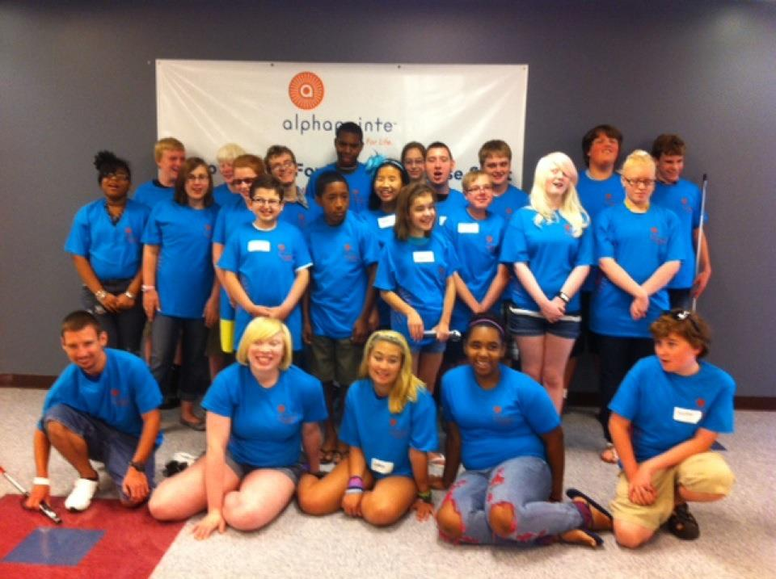 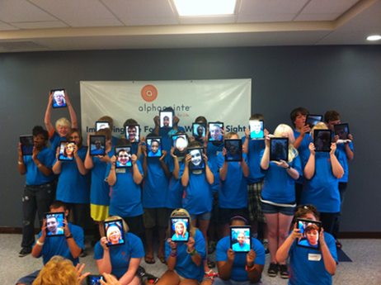



**Technology Camp**

**Nomination/Registration Form**

Student Name: ________________________________________________________________

Parents Names: _________________________________________________________________

Address: ______________________________________________________________________

______________________________________________________________________________

Phones (home): ________________________Phones (cell or work): _______________________________

E-mail(s):_____________________________________________________________________________

Age: __________ Current Grade: _________ School: __________________________________________

Teacher for visually impaired (TVI): _______________________________________________________

TVI Phone : ________________________________ E-mail: _____________________________________

Visual Diagnosis: _______________________________________________________________________

_____________________________________________________________________________________

Other considerations: ___________________________________________________________________

_____________________________________________________________________________________

Description of current technology skills: _____________________________________________________________________________________________

Register online at www.alphapointe.org

Or fax or e-mail completed form to (816) 237-2065 or

[cberry@alphapointe.org](mailto:cberry@alphapointe.org) [sbaker@alphapointe.org](mailto:sbaker@alphapointe.org)