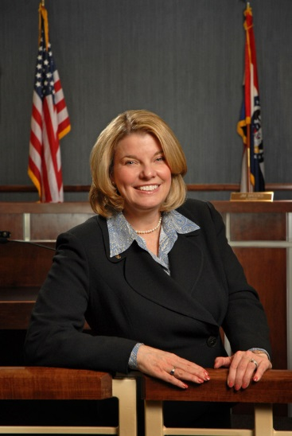

The Alphapointe Board of Directors is pleased to announce the addition of Kathryn Dusenbery as a new board member for Alphapointe. For the last 20 years, Kathryn has given to the local community as a community activist and an elected official. She is an accomplished journalist, business and community leader; having served as an alderman for seven years, Parkville, Missouri Mayor for two-terms and Platte County Commissioner for one term. During her years of service, she has developed relationships with influential contributors to our metropolitan community and has been part of many fund raising campaigns for numerous area nonprofits.