Thank you to our 2015 C&C Group Alphapointe Pro-Am Sponsors

Title Sponsor


Player’s Premium Sponsor   | Awards Dinner Sponsor  
Youth Instructional Clinic Sponsor   | Instructional Clinic Sponsor  
Halfway House Sponsor   | Clubhouse Sponsor  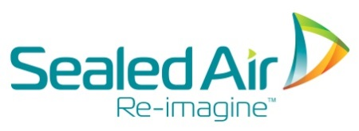
Par 3 Sponsor



